Assignment – I (10%)
COMP 3123 – Full Stack Development – I

GitHub Project Link: https://github.com/Qanntu/101470163_COMP3123-Assignment1

- Sample User Detail:
{
"username": "liz",
"email": "liz@example.com",
"password": "lizpassword"
}

- MongoDB Console Screenshots:
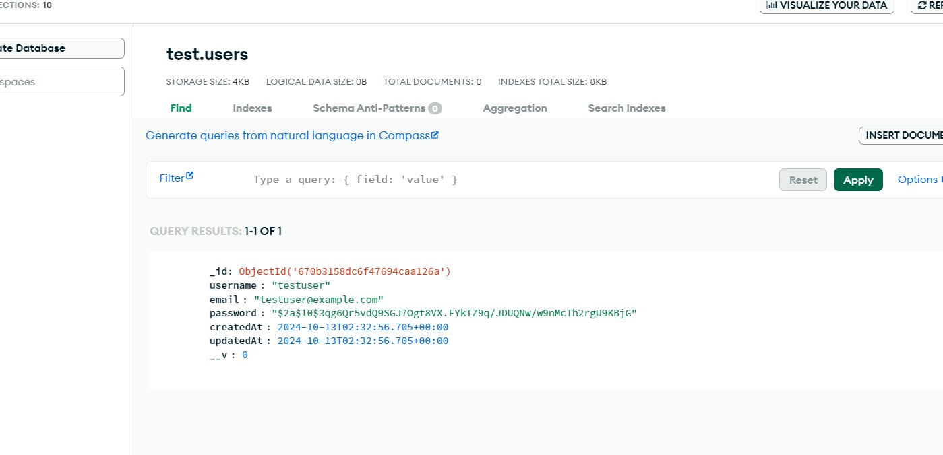
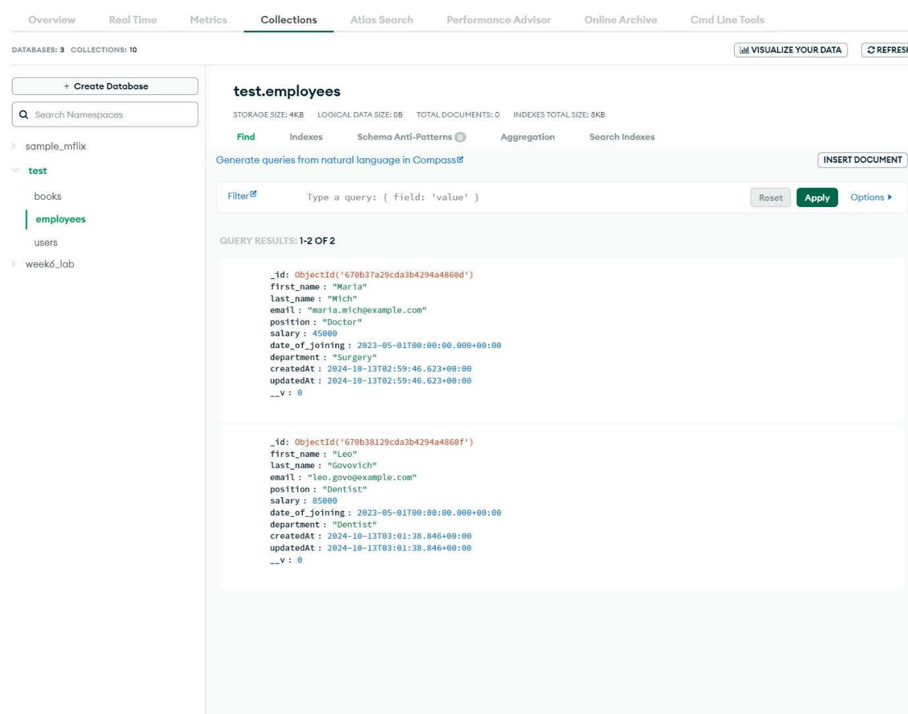

- Screenshots:
- User login
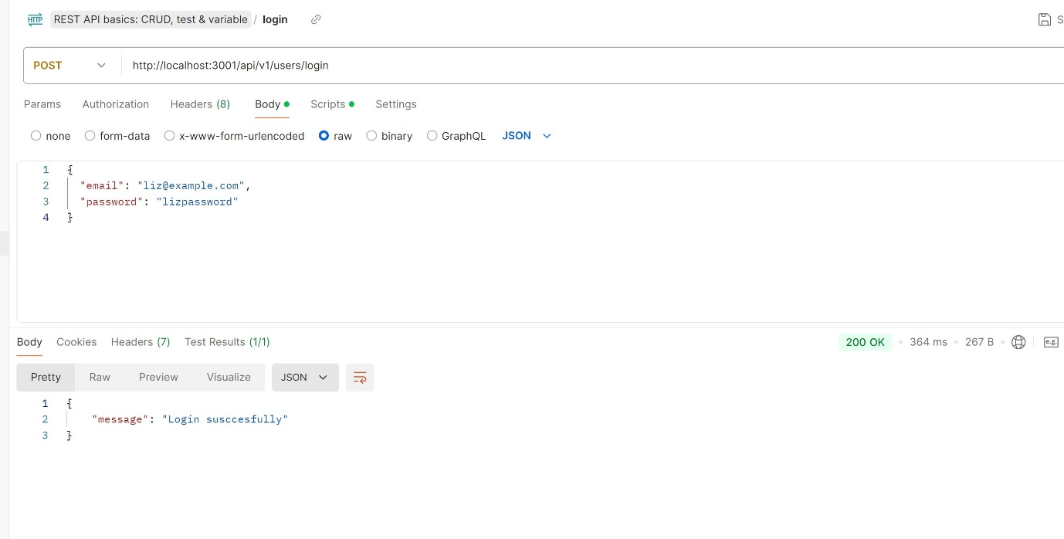
- User Signup

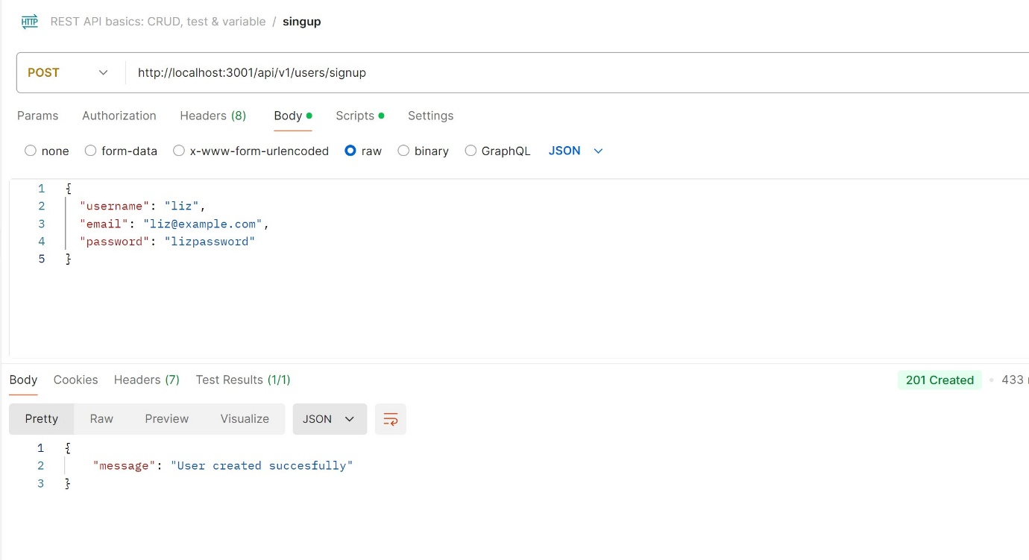
- Delete employee by ID
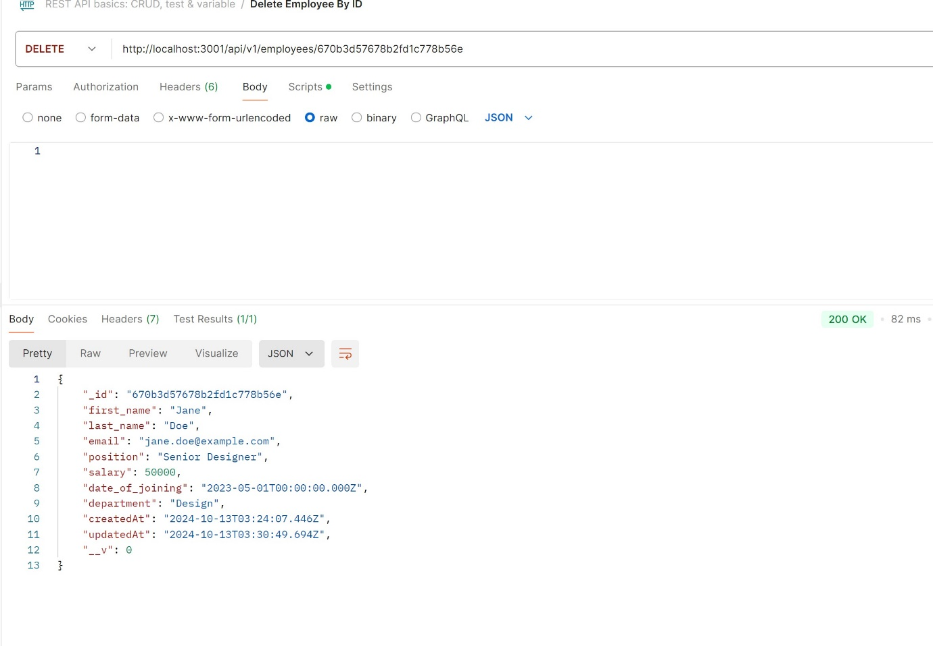
- Update employee by ID
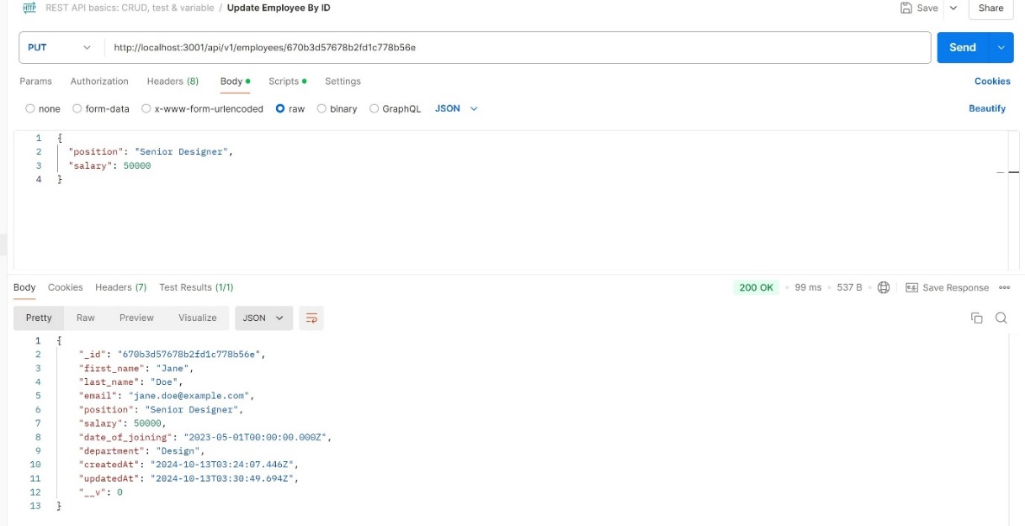
- Get employee by ID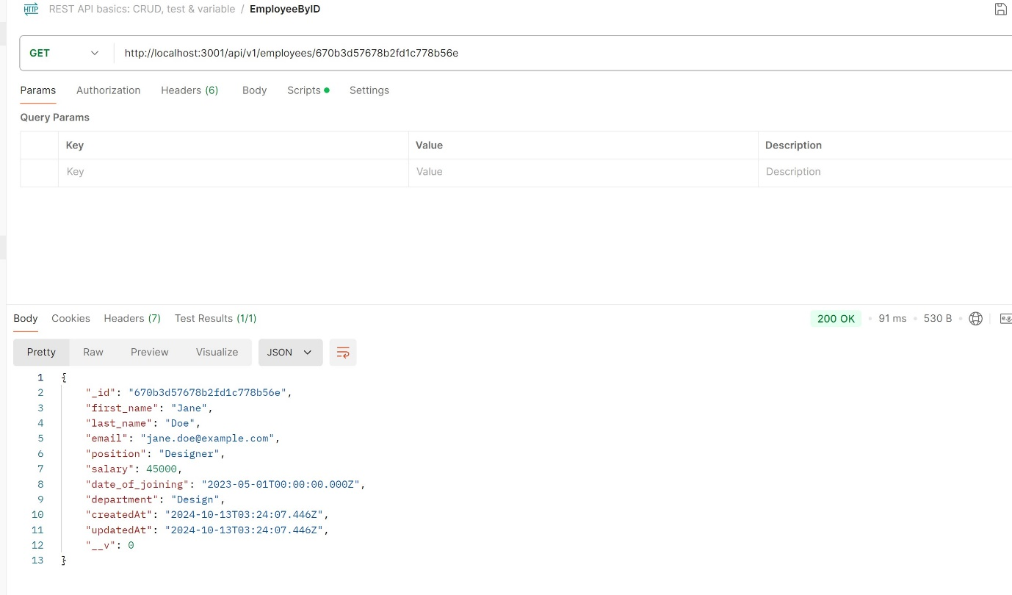f. Create a new employee
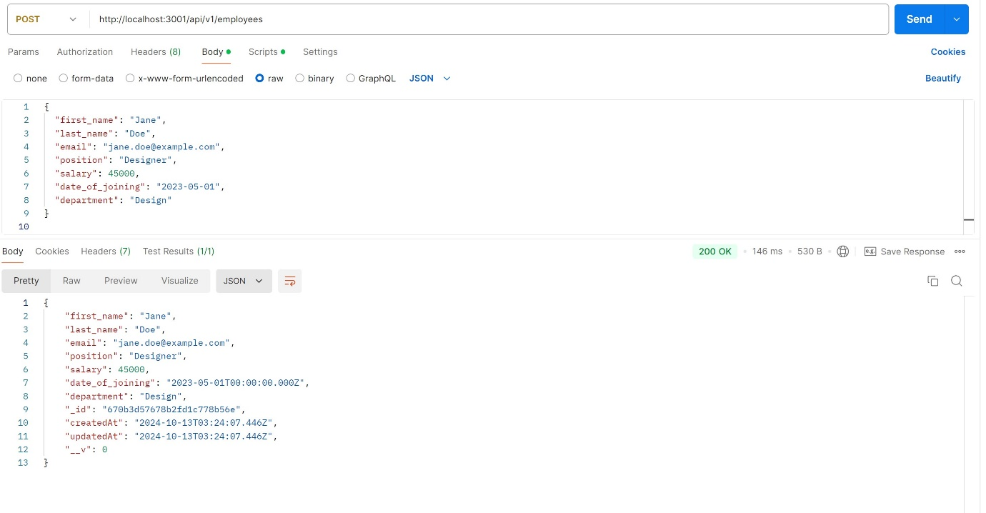

g. Get all employees

